Anubis Configuration
The anubis background process restarts processes listed in the startup info record. In order to stop any of these processes, you must first stop anubis, otherwise anubis will restart them on its next scheduled run time. This configuration will schedule the Anubis process to wake up every 60 seconds and execute the RAD app defined in the schedule record.
- Create an anubis agent record.
- Create an anubis schedule record.
- Start the anubis process.

Create an anubis agent record
- Type the following command into the ServiceCenter command line: info
- Type the anubis agent record information.
- 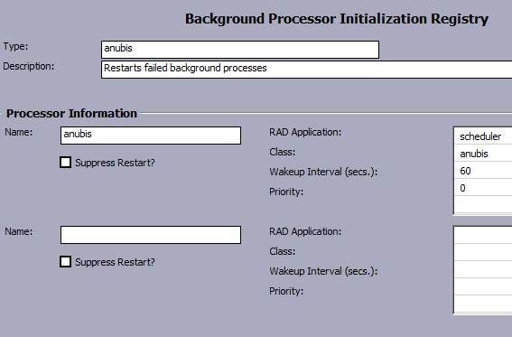
- Click Add.
Note: You can also add the anubis background process to the startup record to have ServiceCenter automatically start anubis.
- 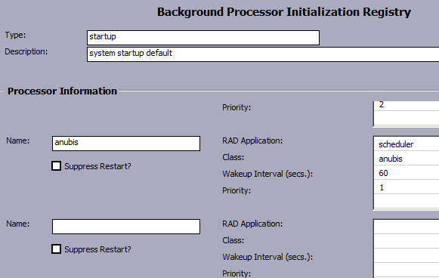

Create an anubis schedule record
You can create an anubis schedule record to restart stopped background processes automatically.
- Type the following command into the ServiceCenter command line: sch
- The schedule.looksee.g form opens
- Type or select the following information.
Field | Description
Name | Type anubis.
Class | Type anubis.
Expiration | Type or select any date and time prior to the current time.
Scheduled Class | Type anubis.
Repeat Interval | Type or select a repeat interval. For example, type 00:00:30 for a thirty-second repeat interval.
Application | Type apm.anubis.
- 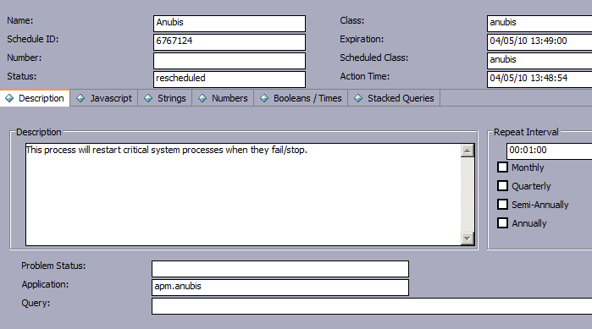
- Click Add.

Start the anubis process
- Type the following command into the ServiceCenter command line: status
- Select “Start Scheduler” button
- Double click on “anubis” process
- 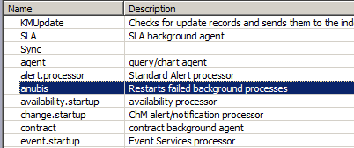

Stop/Restart the anubis process
- Type the following command into the ServiceCenter command line: status
- Select “anubis” line and enter “k” in the command field and press “Execute Commands”
- 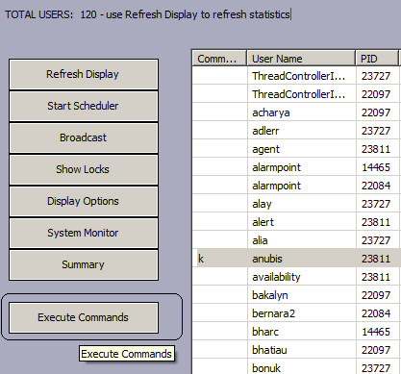
- The “anubis” process has to be stopped before prior to stopping any other HPSM process(es) to prevent “anubis” from restarting it/them.
- Follow the “Start Anubis Process” procedures for restarting anubis.

